**Agenda**

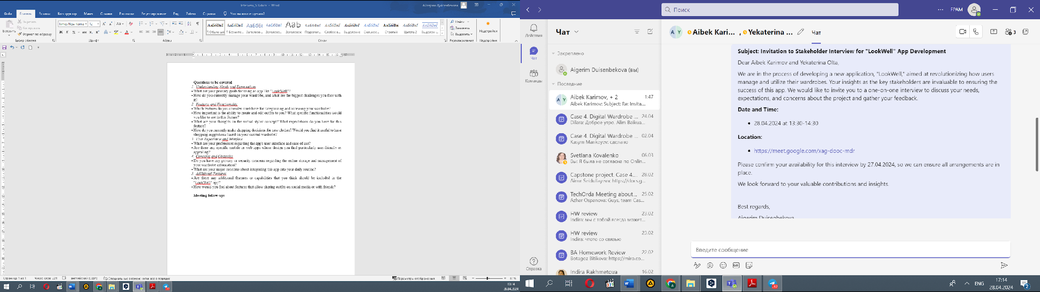

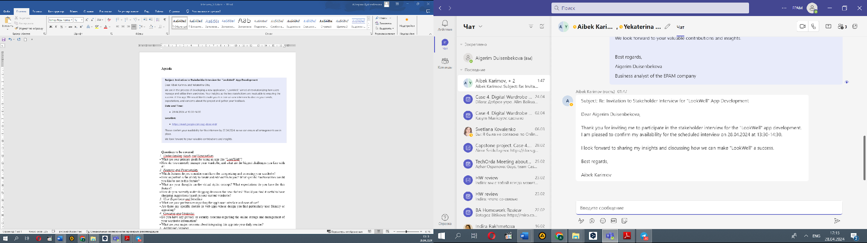

**Questions to be covered**

1. Understanding Needs and Expectations

What are your primary goals for using an app like "LookWell"?

How do you currently manage your wardrobe, and what are the biggest challenges you face with it?

1. Features and Functionality

Which features do you consider must-have for categorizing and accessing your wardrobe?

How important is the ability to create and edit outfits to you? What specific functionalities would you like to see in this feature?

What are your thoughts on the virtual stylist concept? What expectations do you have for this feature?

How do you currently make shopping decisions for new clothes? Would you find it useful to have shopping suggestions based on your current wardrobe?

1. User Experience and Interface

What are your preferences regarding the app's user interface and ease of use?

Are there any specific mobile or web apps whose design you find particularly user-friendly or appealing?

1. Concerns and Obstacles

Do you have any privacy or security concerns regarding the online storage and management of your wardrobe information?

What are your major concerns about integrating this app into your daily routine?

1. Additional Features

Are there any additional features or capabilities that you think should be included in the "LookWell" app?

How would you feel about features that allow sharing outfits on social media or with friends?

**Meeting recording link:**

[**https://drive.google.com/file/d/1B-W6p6AhOjqPLqO7F7dP_Zg9RJYaIl8E/view?usp=drive_link**](https://drive.google.com/file/d/1B-W6p6AhOjqPLqO7F7dP_Zg9RJYaIl8E/view?usp=drive_link)

**Meeting follow-ups**

1. Understanding Expectations:
   * Stakeholders expressed a desire for effective wardrobe management and easy visualization of their entire wardrobe through the app to avoid repetitive purchases and better manage clothing combinations.
2. Addressing Concerns:
   * Major concerns include privacy and data security, the adaptation of users to regularly using the app, and its market acceptance among different age groups.
3. Desired Features:
   * The app should allow users to add clothing items by taking photos, buying items through the app, and organizing clothes by type, event, or season.
   * Innovative features like scanning items via QR code or barcode, and adding items by typing URLs were suggested.
   * The possibility of tagging clothes and creating folders (e.g., favorites) was seen as helpful.
   * A virtual stylist feature that suggests outfits based on weather and personal calendar was highly favored.
   * Gamification elements and environmental impact information were also suggested as beneficial additions.
4. Integration into Daily Routines:
   * The app should minimize the time users spend choosing outfits and help them manage their wardrobe more efficiently. Features like color and seasonal categorization were highlighted as particularly useful.
5. User Interface and Experience:
   * A simple, intuitive, and stylish interface was emphasized. Examples of user-friendly designs from apps like Pinterest were mentioned as benchmarks.
6. Language and Platform Inclusivity:
   * Multi-language support (especially Russian, Kazakh, and English) and cross-platform availability for both iOS and Android devices were deemed critical to cater to a diverse user base.
7. Future Considerations:
   * A desktop version could be beneficial, especially for users who prefer larger displays or do not frequently use smartphones.
8. Next Steps:
   * Collate all feedback to influence the app’s development roadmap.
   * Plan further discussion sessions and continue to engage with participants to refine and enhance the app’s features.